Replace and modernize legacy VPN architectures with a

Could-native Zscaler Zero trust solution to reduce

Attack surface and lateral movement

Overview:-
Replacing legacy VPN architectures with a cloud-native Zscaler Zero Trust solution helps organizations improve security and modernize remote access. Traditional VPNs provide users with broad access to the internal network once they are connected, which increases the attack surface and allows attackers to move laterally across systems if a device is compromised. In contrast, the Zero Trust model follows the principle of “never trust, always verify,” where users are continuously authenticated and given access only to specific applications rather than the entire network. Zscaler’s cloud-native platform securely connects users directly to applications through the cloud, hiding internal resources from the public internet. This approach reduces the attack surface, prevents lateral movement, improves scalability, and provides secure access for users from anywhere without relying on traditional VPN infrastructure

S.NO | NAME | COLLEGE | CONTACT
01 | Aadhisha Mythiri | Maharani arts & science college | 9095627251
02 | Karthika.M | Maharani arts & science college | 9994127237
03 | Kiruthika.N | Maharani arts & science college | 9345306164
04 | Sabareeswari.P | Maharani arts & science college | 9750641777
List of teammates–

List of Vulnerability Table:

S.no | Vulnerability Name | CWE - No
1 | Improper Sanitization of File Paths | CWE- 284: Improper Access  Control
2 | Invalid Certificate | CWE-395: Improper  Certificate Validation
3 | Missing X-Frame-Options Header | CWE-1021: Design Improper Restriction of Rendered UI Layers or Frames
4 | X-Content-Type Options Header Missing | CWE -918: Server-Side  Request Forgery (SSRF)
5 | Drupal Ajax API shows JSONP not disabled by default | CWE-937,1035: OWASPTop Ten 2013,2017 Category A9 - Using Components with Known Vulnerabilities
6 | Drupal Api Vulnerability | CWE-20: Improper Input  Validation
7 | Improper API Filtration | CWE-79: ImproperNeutralisation of Input During Web Page Generation  ('Cross-site Scripting'
8 | Denial of Service | CWE -400: Uncontrolled  Resource Consumption
9 | TLS Version 1.0 Protocol Detection | CWE-327: Use of a Broken  or Risky Cryptographic Algorithm
10 | web.config File Information Disclosure | CWE-497: Exposure of Sensitive System Information to an Unauthorised ControlSphere

REPORT:

- Vulnerability Name: Improper Sanitization of File Paths
- CWE- 284: Improper Access Control
- OWASP Category: A01:2021-Broken Access Control
- Description: The product does not restrict or incorrectly restricts access to a resource from an unauth orized actor
- Business Impact: This vulnerability is significant, as it can lead to unauthorized access to sensitive data or files, potentially causing data breaches, privacy violations, and loss of user trust. Affected sites may also require configuration changes after applying a security release
- ZPA: If TLS 1.0 is detected in an environment using Zscaler Private Access, it indicates that some applications or servers are still allowing an outdated encryption protocol. This can create security and compliance risks for the organization.

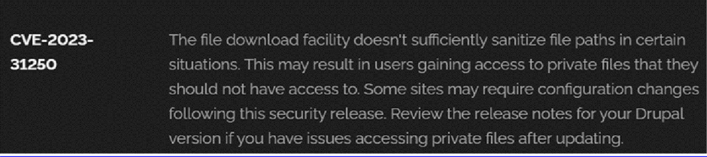
Recommendation:
- Apply Security Updates: The primary recommendation is to apply the security update provided by Drupal as soon as it becomes available. Security updates typically include fixes for known vulnerabilities like this one.
- Review Configuration: After applying the update, review your Drupal site's configuration to ensure that private files remain protected as intended. Make any necessary adjustments to your site's file permissions or access controls.
- Regular Audits: Conduct regular security audits and vulnerability assessments to identify and address potential security issues in your Drupal site.
- Access Control: Implement strong access controls to ensure that only authorized users can access private files. Review and restrict file access permissions as needed.
- Data Minimization: Minimize the amount of sensitive data stored on your Drupal site. Only store data that is necessary for your site's functionality

2).Vulnerability Name: Invalid Certificate
CWE-395: Improper Certificate Validation
OWASP Category: A07:2021 – Identification and Authentication Failures
Description: When a certificate is invalid or malicious, it might allow an attacker to spoof a trusted entity by interfering in the communication path between the host and client. The product might connect to a malicious host while believing it is a trusted host, or the product might be deceived into accepting spoofed data that appears to originate from a trusted host
Business Impact: Improper certificate validation can lead to a range of security threats which includes Man-in-the-middle attacks(Attackers can intercept communication between two parties and read or modify the data exchanged between them),Data breaches:(Attackers can gain unauthorized access to sensitive information or sensitive systems, leading to data breaches),Malware distribution(Attackers can use fake digital certificates to distribute malicious software or infect systems with malware)

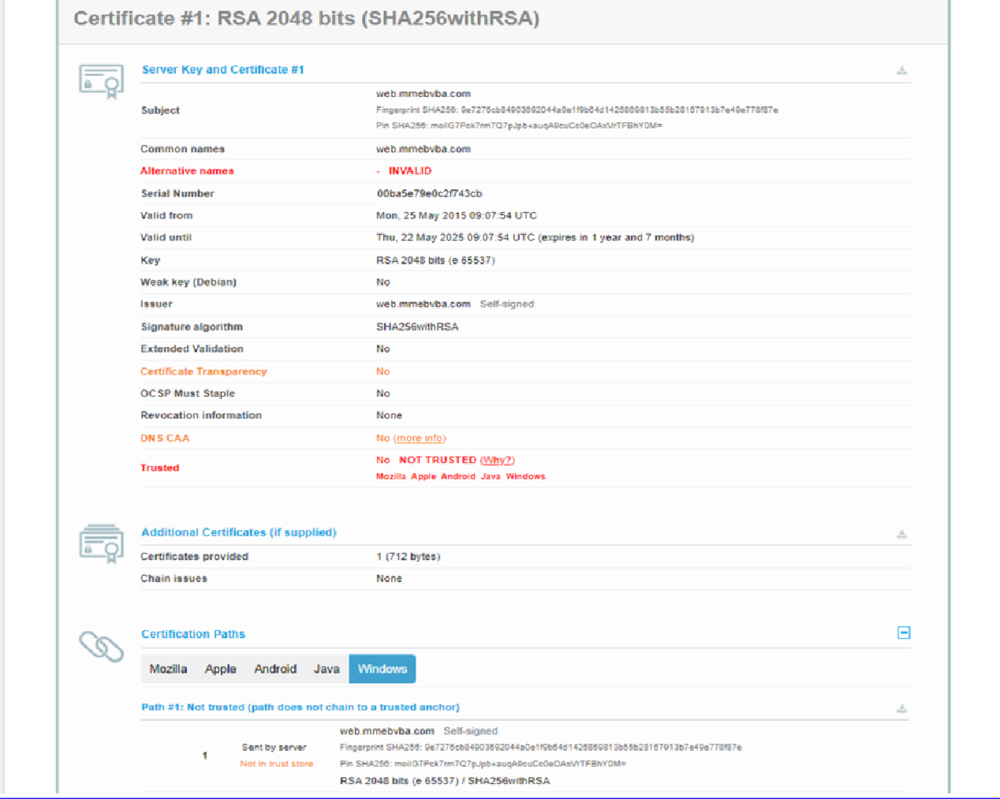

Recommendation:
- Use trusted certificate authorities: Only trust digital certificates issued by well-known and trusted certificate authorities.
- Verify certificate chains: Verify that the certificate presented by the remote party is valid and issued by a trusted certificate authority. Verify the entire certificate chain, including intermediate certificates.
- Check certificate revocation status: Check the revocation status of the certificate presented by the remote party to ensure that it has not been revoked.
- Use certificate pinning: Implement certificate pinning to ensure that the communication only occurs with the exact certificate or certificate authority specified.
- Keep software up to date: Keep software and security protocols up to date, as new vulnerabilities and security patches are regularly released.

3).Vulnerability Name: Missing X-Frame-Options Header
CWE-1021: Design Improper Restriction of Rendered UI Layers or Frames

OWASP Category: A04:2021-Insecure Design
Description: A web application is expected to place restrictions on whether it is allowed to be rendered within frames, iframes, objects, embed or applet elements. Without the restrictions, users can be tricked into interacting with the application when they were not intending to.
Business Impact: This enables path to the attackers to manipulate or gain unauthorized access to user interface elements, potentially leading to deceptive or malicious user interactions. This can result in data leakage, fraud, user distrust, and reputational damage, undermining the integrity and trustworthiness of the application and causing financial losses

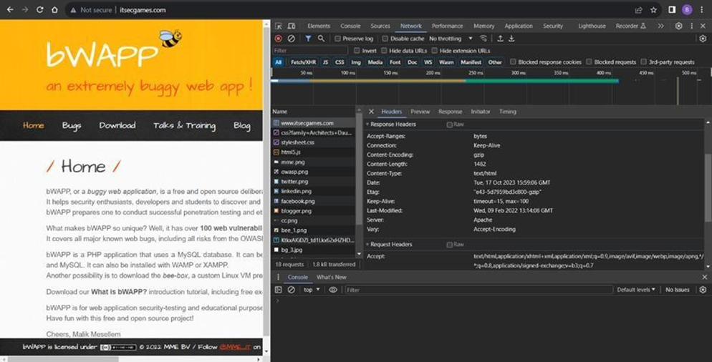

Recommendation:
- Implement Proper UI Layer Access Controls: Enforce access controls to restrict access to UI layers or frames based on user privileges.
- Use Session and Authentication Management: Ensure robust session management and user authentication mechanisms to prevent unauthorized access.
- Implement Content Security Policies (CSP): Use CSP headers to control where resources can be loaded from and mitigate against frame-based attacks.
- Keep Software and Libraries Updated: Stay current with software updates and patches to address known security issues

4).Vulnerability Name: X-Content-Type Options HeaderMissing
CWE -918: Server-Side Request Forgery (SSRF)
OWASP Category: A10:2021 – Server-Side Request Forgery (SSRF)
Description: The web server receives a URL or similar request from an upstream component and retrieves the contents of this URL, but it does not sufficiently ensure that the request is being sent to the expected destination.

Business Impact: The header missing impact Data Exposure(Attackers might force the server to render sensitive data as HTML, leading to data exposure),Security Risks(Content type manipulation can increase security risks, potentially leading to breaches, data leaks, and unauthorized access), Brand and Reputation Damage(Successful attacks that exploit SSRF vulnerabilities can harm the organization's reputation and trustworthiness)

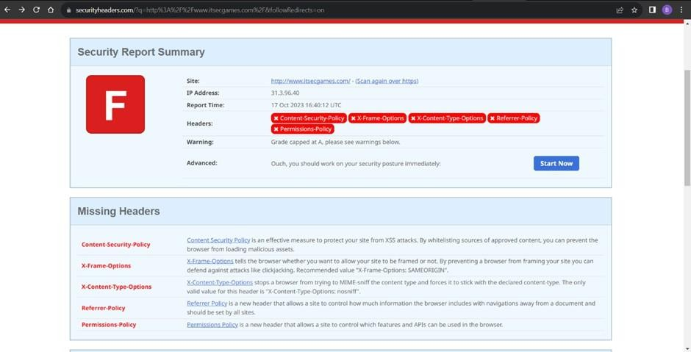

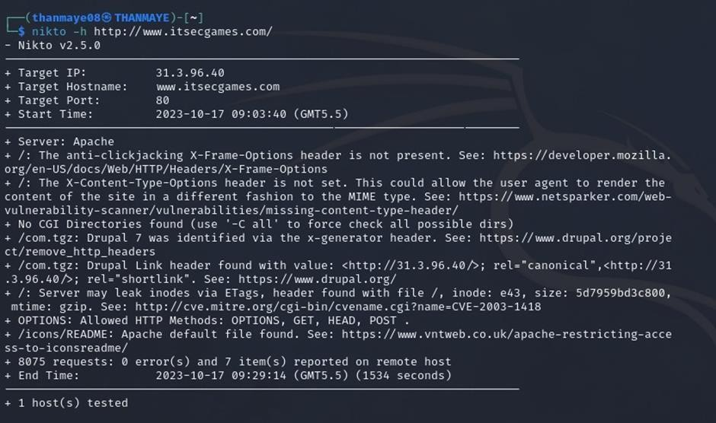

Recommendation:
- Implement "X-Content-Type-Options" Header: Configure the "X-Content-Type-Options" header with the value "nosniff" in your web server or application to prevent content type sniffing.

- Secure SSRF: To directly mitigate SSRF vulnerabilities, ensure proper input validation, access controls, and allow-list-based URL validation to prevent attackers from making unauthorized requests to internal resources.
- Security Headers: Implement other security headers like "X-Frame-Options" and "Content-Security-Policy" to further enhance security and mitigate various types of web-based attacks.

While the "X-Content-Type-Options" header may not be a direct countermeasure to SSRF,it is a valuable security control that, when configured correctly, can help protect against content type- based attacks that may be exploited in SSRF scenarios.

5).Vulnerability Name: Drupal Ajax API shows JSONP not disabled by default

CWE-937,1035: OWASP Top Ten 2013,2017 Category A9 - Using Components with Known Vulnerabilities
OWASP Category: A06:2021-Vulnerable and Outdated Components

Description: Vulnerable and outdated components refer to using software libraries, modules, or dependencies within a web application that have known security issues or are not updated to the latest secure versions. This can include plugins, frameworks, or APIs that are no longer maintained or have publicly documented vulnerabilities.
Business Impact: The presence of vulnerable and outdated components in a web
application poses significant security risks. Attackers can exploit these weaknesses to
gain unauthorized access, inject malicious code, steal sensitive data, or disrupt the
system's operation. The potential business impacts include compromised user data,
damaged reputation, legal consequences, and financial losses due to breach recovery
and remediation efforts.
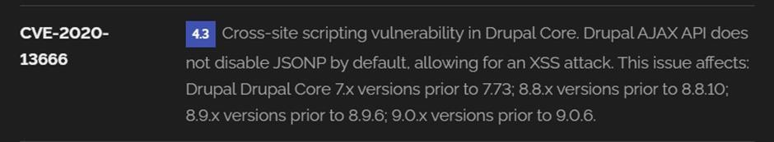

Recommendation:
- Regular Updates: Keep all components, libraries, and dependencies up to date by applying security patches and upgrades.
- Vulnerability Scanning: Conduct periodic vulnerability assessments to identify and address potential issues.
- Dependency Management: Implement a strategy for managing third-party dependencies, including continuous monitoring of their security status.
- Security Testing: Perform regular security testing, including penetration testing and code review, to identify and remediate vulnerabilities.
- Change Control: Maintain a change management process to assess the impact of new components and ensure they don't introduce new vulnerabilities.

6).Vulnerability Name: Drupal ApiVulnerability
CWE-20: Improper Input Validation
OWASP Category: A03:2021 – Injection
Description: The product receives input or data, but it does not validate or incorrectly validates that the input has the properties that are required to process the data safely and correctly.
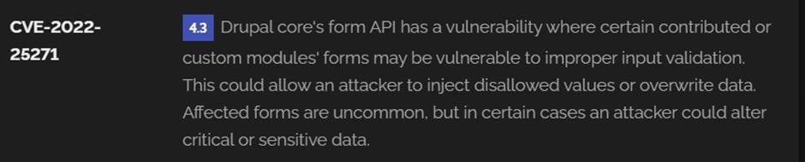
Business Impact: The impact of a successful SQL injection attack can be devastating for businesses. It can result in unauthorized access to sensitive information, data theft, financial losses, damage to reputation, and legal consequences. Depending on the nature of the application and data involved, SQL injection can lead to compliance violations, customer trust erosion, and operational disruption.

Recommendation:
- Input Validation: Implement rigorous input validation on all user inputs and ensure that only safe, sanitized data is passed to the database.
- Parameterized Queries: Use parameterized queries or prepared statements to separate SQL code from user input, preventing malicious injections.
- Escaping User Input: If parameterized queries are not feasible, escape user input before incorporating it into SQL queries to neutralize special characters.

- Least Privilege Principle: Limit the permissions and access rights of database accounts to the minimum required for specific tasks to minimize the potential damage of an attack.
- Web Application Firewalls (WAF): Employ WAFs to filter and block malicious SQL injection attempts.
- Regular Security Testing: Conduct regular security assessments, including penetration testing, to identify and address vulnerabilities.

7).Vulnerability Name: Improper API Filtration

CWE-79: Improper Neutralization of Input During Web Page Generation ('Cross-site Scripting')

OWASP Category: A07-2017: Cross-site Scripting (XSS)
Description: The product does not neutralize or incorrectly neutralizes user-controllable input before it is placed in output that is used as a web page that is served to other users.
Business Impact: If exploited, this vulnerability allows attackers to inject malicious scripts into web pages, which can be viewed by other users. The potential business impacts include data theft, unauthorized access, compromised user accounts, damaged reputation, and financial losses. Attackers can use XSS to steal sensitive information, such as user credentials, personal data, or financial details, leading to regulatory compliance violations and legal liabilities. Additionally, defacement or manipulation of website content can erode customer trust and result in lost revenue.
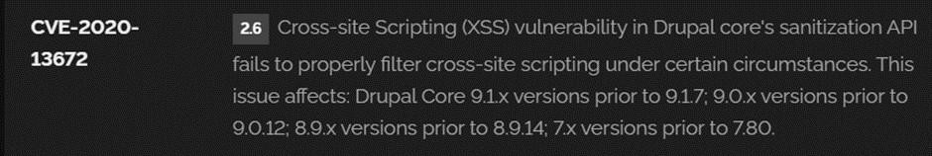

Recommendation:

- Update and Patch: Ensure that Drupal and all related modules and components are up to date with the latest security patches to mitigate known vulnerabilities.
- Input Validation: Implement strong input validation and output encoding to sanitize user inputs and prevent the injection of malicious scripts.
- Content Security Policy (CSP): Implement CSP headers to restrict the sources from which content can be loaded, reducing the risk of XSS.

- Secure Coding Practices: Train developers in secure coding practices, emphasizing the importance of validating and escaping user inputs.
- Security Scanning: Conduct regular security scans and penetration tests to identify and address XSS vulnerabilities.

8).Vulnerability Name: Denial of Service
CWE -400: Uncontrolled Resource Consumption
OWASP Category:
Description: The Denial of Service (DoS) attack is focused on making a resource (site, application, server) unavailable for the purpose it was designed. There are many ways to make a service unavailable for legitimate users by manipulating network packets, programming, logical, or resources handling vulnerabilities, among others. If a service receives a very large number of requests, it may cease to be available to legitimate users. In the same way, a service may stop if a programming vulnerability is exploited, or the way the service handles resources it uses.
Sometimes the attacker can inject and execute arbitrary code while performing a DoS attack in order to access critical information or execute commands on the server. Denial-of-service attacks significantly degrade the service quality experienced by legitimate users. These attacks introduce large response delays, excessive losses, and service interruptions, resulting in direct impact on availability.

Business Impact: If successfully exploited, it involves overwhelming a system or application with excessive demands on its resources. This can lead to a range of disruptive consequences. The targeted system may experience significant slowdowns, or even complete unresponsiveness, making it difficult or impossible for legitimate users to access. Critical resources like CPU, memory, and network bandwidth can become depleted, causing further degradation in performance. In severe cases, the exploited vulnerability may lead to system crashes or failures, potentially resulting in data loss. This disruption not only impacts business productivity and financial stability but also risks reputational damage, eroding customer trust and confidence.
Additionally, organizations may face regulatory compliance issues if the uncontrolled resource consumption leads to violations of service level agreements or industry standards. Mitigating this vulnerability requires proactive resource management practices and a well-prepared incident response plan to minimize the potential impacts on business operations and customer satisfaction.

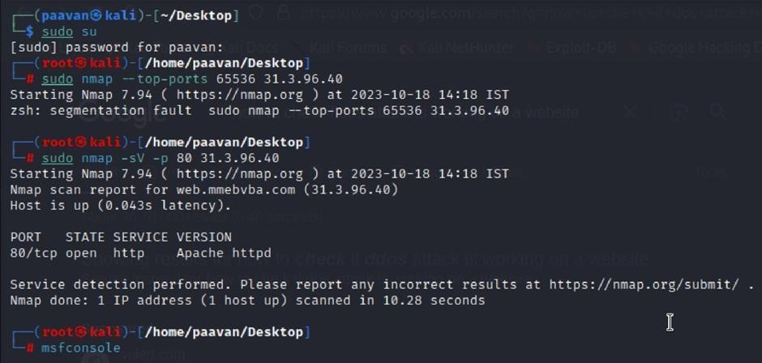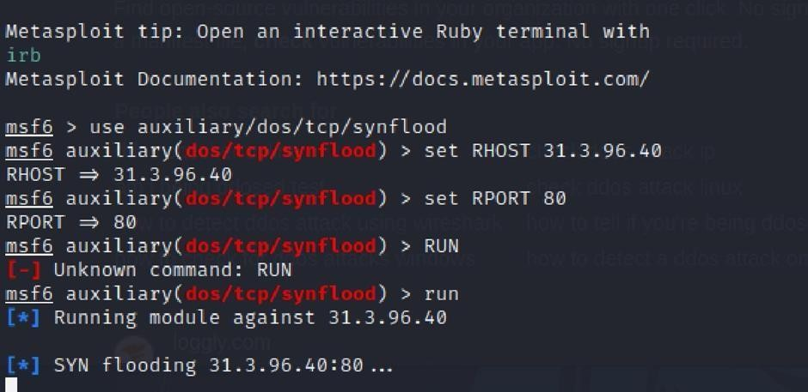

Recommendation: Employ a robust Web Application Firewall (WAF) capable of filtering and mitigating suspicious traffic targeting port 80. Configure it to block excessive requests or patterns indicative of an attack. Utilise load balancing techniques to distribute traffic across multiple servers, ensuring no single server becomes overwhelmed. Additionally, implement rate limiting and throttling mechanisms to restrict the number of requests a single IP address can make within a defined time frame. Regularly monitor traffic patterns and set up alerts to detect unusual spikes in activity, enabling rapid response to potential attacks. Finally, keep software and systems up-to-date with the latest security patches to address known vulnerabilities that attackers may exploit.

9).VulnerabilityName:TLSVersion 1.0 Protocol Detection
CWE-327: Use of a Broken or Risky Cryptographic Algorithm
OWASP Category: A02:2021-Cryptographic Failures
Description: The product uses a broken or risky cryptographic algorithm or protocol.

Business Impact: TLS 1.0 is an outdated and vulnerable encryption protocol, and its use can expose sensitive data to potential security threats. This not only jeopardizes the integrity of customer information and payment details but also tarnishes the company's reputation. The business may face legal consequences, loss of customer trust, and decreased revenue as security- conscious users avoid the site due to its security vulnerabilities. Immediate action is necessary to upgrade to a more secure TLS version to safeguard data, ensure compliance, and maintain customer confidence.

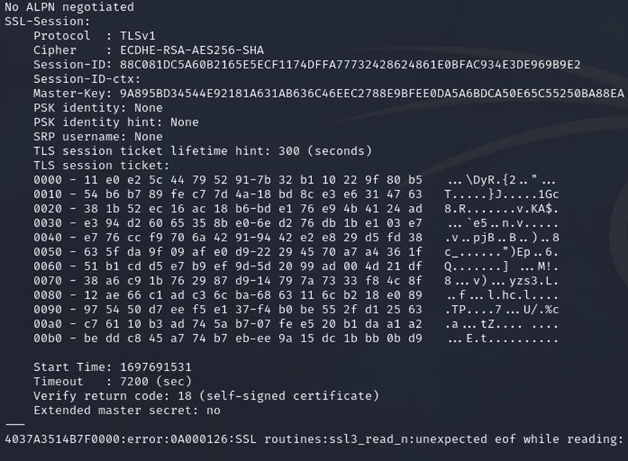

Recommendation:

- Upgrade to a Secure TLS Version: Transition to a more secure TLS version, such as TLS 1.2 or TLS 1.3. This will provide stronger encryption and improved security against modern threats.
- Regularly Update SSL/TLS Configuration: Keep your SSL/TLS configuration up to date to ensure it aligns with the latest security best practices and vulnerabilities.
- Implement a Strong Cryptographic Suite: Use strong cipher suites and secure configurations to further enhance security. Disable weak ciphers and outdated protocols.
- Compliance Checks: Ensure that your website complies with relevant data protection regulations and industry standards (e.g., GDPR, PCI DSS) to avoid legal issues.

10).Vulnerability Name: web.config File Information Disclosure

CWE-497: Exposure of Sensitive System Information to an Unauthorized Control Sphere

OWASP Category: A3:2017-Sensitive Data Exposure
Description: An information disclosure vulnerability exists in the remote web server due to the disclosure of the web.config file. An unauthenticated, remote attacker can exploit this, via a simple GET request, to disclose potentially sensitive configuration information.
Business Impact: It exposes sensitive configuration details, including database connection strings and encryption keys, to potential attackers. This could lead to unauthorized access, data breaches, and system compromise. The impact includes financial losses, damage to reputation, and legal liabilities as the organization's security and customer trust are compromised

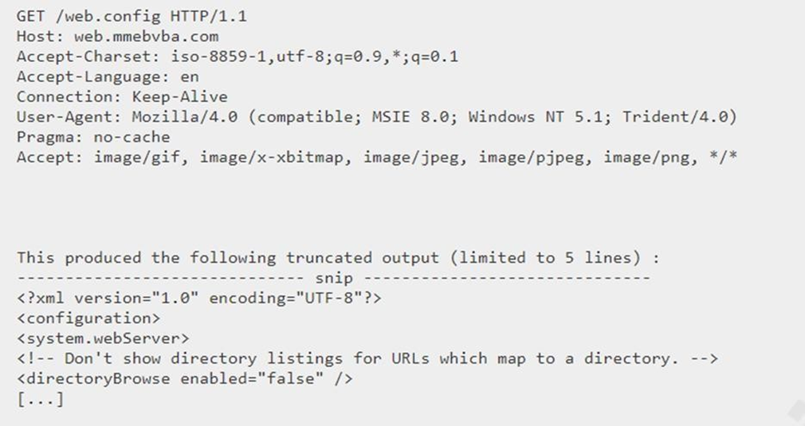

Recommendation:

- Implement proper access controls to restrict access to the web.config file.
- Prevent directory traversal and ensure the web.config file cannot be directly accessed through the web server.
- Encrypt sensitive data within the configuration file.
- Regularly review and update the web.config file, removing any unnecessary sensitive information.
- Ensure that the web.config file is properly secured and not accessible to unauthorized users.

Stage 2
Overview :-

Nessus is a vulnerability scanner developed by Tenable, Inc. It is a remote scanner, meaning that it does not need to be installed on the target host to scan it. Nessus works by sending a variety of probes to the target host in order to identify vulnerabilities. These probes can include network traffic, operating system commands, and application requests.

Nessus uses a plugin-based architecture. Plugins are small pieces of code that are designed to identify specific vulnerabilities. There are over 1200 plugins available for Nessus, covering a wide range of vulnerabilities in operating systems, applications, and network devices.

When Nessus scans a host, it first uses a discovery plugin to identify the operating system and services running on the host. Once the host has been discovered, Nessus runs a series of plugins to test for vulnerabilities. For each vulnerability that Nessus finds, it provides a detailed report that includes the severity of the vulnerability, the steps to reproduce the vulnerability, and the steps to remediate the vulnerability.

s.no | Vulnerability name | Severity | plugins
1 | TLS Version 1.0 Protocol  Detection | MEDIUM | 104743
2 | TLS Version 1.1 Protocol  Deprecated | MEDIUM | 157288
3 | SSL/TLS Diffie-Hellman Modulus  <= 1024 Bits (Logjam) | LOW | 83875
4 | ICMP Timestamp Request Remote  Date Disclosure | INFO | 10114

Vulnerability 1: - 104743 - TLS Version 1.0 Protocol Detection
Severity: - MEDIUM
Plugin: - 104743
Port: - 443
Description: - The remote service accepts connections encrypted using TLS 1.0. TLS 1.0 has a number of cryptographic design flaws. Modern implementations of TLS 1.0 mitigate these problems, but newer versions of TLS like 1.2 and 1.3 are designed against these flaws and should be used whenever possibleAs of March 31, 2020, Endpoints that aren’t enabled for TLS 1.2 and higher will no longer function properly with major web browsers and major vendors.
PCI DSS v3.2 requires that TLS 1.0 be disabled entirely by June 30, 2018, except for POS terminals (and the SSL/TLS termination points to which they connect) that can be verified as not being susceptible to any known exploits
Solution: - Enable support for TLS 1.2 and 1.3, and disable support for TLS 1.0.
Business Impact: -Continued use of TLS 1.0's encryption, known for its inherent cryptographic flaws, exposes the organization to heightened security risks, increasing the likelihood of data breaches and cyberattacks. This vulnerability jeopardizes compliance with industry standards, specifically PCI DSS v3.2, which mandates the complete cessation of TLS 1.0 use. Non- compliance risks regulatory penalties and erodes customer trust. Moreover, endpoints that lack support for TLS 1.2 and higher will experience impaired functionality with major web browsers
and vendors, potentially leading to lost business opportunities and damage to the organization's reputation. Addressing this vulnerability is imperative to mitigate these multifaceted risks and maintain a secure and trustworthy online presence.
Vulnerability 2: - 157288 - TLS Version 1.1 Protocol Deprecated
Severity: - MEDIUM
Plugin: - 157288
Port: - 443
Description: - The remote service accepts connections encrypted using TLS 1.1. TLS 1.1 lacks support for current and recommended cipher suites. Ciphers that support encryption before MAC computation, and authenticated encryption modes such as GCM cannot be used with TLS 1.1 As of March 31, 2020, Endpoints that are not enabled for TLS 1.2 and higher will no longer function properly with major web browsers and major vendors.
Solution: - Enable support for TLS 1.2 and/or 1.3, and disable support for TLS 1.1.

Business Impact: -The continued use of TLS 1.1 with its lack of support for modern cipher suites and advanced encryption methods jeopardizes the organization's security posture, increasing vulnerability to cyber threats and potential data breaches. Additionally, endpoints not upgraded to support TLS 1.2 and higher will encounter compatibility issues with major web browsers and vendors, impacting user experience and potentially leading to missed business opportunities. Swift remediation of this vulnerability is essential to mitigate security risks and ensure seamless interactions with web browsers and vendors, preserving the organization's reputation and operational efficiecncy

Vulnerability Name: - 83875 - SSL/TLS Diffie-Hellman Modulus <= 1024 Bits (Logjam)
Severity: - LOW
Plugin: - 83875
Port: - 443
Description: - The remote host allows SSL/TLS connections with one or more Diffie-Hellman moduli less than or equal to 1024 bits. Through cryptanalysis, a third party may be able to find the shared secret in a short amount of time (depending on modulus size and attacker resources). This may allow an attacker to recover the plaintext or potentially violate the integrity of connections.
Solution: - Reconfigure the service to use a unique Diffie-Hellman moduli of 2048 bits or greater.
Business Impact: - Allowing SSL/TLS connections with weak Diffie-Hellman moduli raises security concerns. An attacker with sufficient resources and computing power could compromise the shared secret relatively quickly, potentially leading to the decryption of sensitive data or the violation of connection integrity. While the severity is low, the risk of data breaches and integrity compromise should not be underestimated, and it is essential to address this vulnerability to maintain data security and user trust.

Vulnerability 4: - 39446 - Apache Tomcat Detection
Severity: - INFO
Plugin: - 39446
Port: - 80
Description: -Nessus was able to detect a remote Apache Tomcat web server
Solution: - n/a
Business Impact: -Is an informational finding that identifies the presence of a remote Apache Tomcat web server. While this information itself does not indicate a security threat or impact on business operations, it can be useful for network administrators and security professionals to be aware of the technologies in use on their network. Understanding the presence of an Apache Tomcat server can be valuable for maintaining and securing web applications, but it does not require immediate action to mitigate a security risk.

Stage 3
Legacy VPN Architecture
Legacy VPN architecture is a network security model that creates an encrypted tunnel between a remote user and an organization's internal network using on-premises hardware appliances like VPN concentrators . Unlike modern solutions, legacy VPNs operate on an "authenticate once, trust indefinitely" principle. Once a user successfully authenticates, they are placed directly onto the internal network with an IP address, effectively becoming a node on that network .
This architecture was designed for a different era when all users were in offices and all applications were in data centers. It relies on the concept of a "trusted internal network" versus an "untrusted external internet"—the castle- and-moat model . The VPN concentrator acts as the drawbridge: once crossed, the user is trusted and granted broad access to internal resources based on their IP address rather than their identity .
Limitations of Legacy VPN
Legacy VPN architectures present significant security and operational challenges in today's distributed work environment. The limitations include:
  - Over-permissioned Access: Once connected, users gain network-level access, meaning a compromised faculty laptop can scan, discover, and attack other systems on the internal network (lateral movement) .
  - Expanded Attack Surface: VPN concentrators must be exposed to the public internet with open ports (typically IPsec on UDP 500 or SSL VPN on TCP 443), making them visible targets for port scanning, brute-force attacks, and vulnerability exploitation .
  - Poor User Experience: Traffic is often "hair-pinned"—routed from the user to the data center and then out to the internet for SaaS applications—causing latency and slow performance .
  - Scalability Challenges: Hardware VPN appliances have hard capacity limits. During peak times (e.g., start of semester), users face connection failures, requiring manual upgrades of expensive hardware .
  - Operational Overhead: IT staff must patch, upgrade, and maintain physical VPN appliances, applying firmware updates and managing certificates .
The Problem: Lateral Movement and Attack Surface
The core security weaknesses of legacy VPNs are the expanded attack surface and the risk of lateral movement. Attack Surface: The VPN concentrator's publicly exposed IP address and open ports invite constant scanning and attacks. Threat actors use tools to identify VPN appliances and exploit known vulnerabilities (e.g., CVE- 2019-11510, a critical Pulse Secure VPN vulnerability). Each exposed port is a potential entry point .
Lateral Movement: Once an attacker gains access via a compromised credential or vulnerability, they inherit the user's network-level access. The internal network, traditionally flat, allows the attacker to move laterally. From a single compromised faculty laptop, they can:
- Scan for other vulnerable servers (e.g., databases, file shares)
- Perform ARP spoofing or pass-the-hash attacks
- Pivot to high-value targets like the student information system or research data repositories
- Deploy ransomware across the network

Zero Trust Architecture
Zero Trust Architecture (ZTA) is a security framework that eliminates the concept of trusted and untrusted networks. It operates on the principle of "never trust, always verify" and "least privilege access." Every access request is fully authenticated, authorized, and encrypted before granting access, regardless of whether the user is in the office or working remotely .
The core tenets of Zero Trust include:
- Assume Breach: Design the network as if attackers are already present.
- Verify Explicitly: Authenticate and authorize based on identity, device health, and context.
- Least Privilege Access: Grant only the minimum access necessary to perform a job function.
- Micro-segmentation: Isolate workloads and users from one another to prevent lateral movement.

Zscaler Zero Trust Solution
Zscaler is a cloud-native security platform that delivers Zero Trust capabilities entirely from the cloud, eliminating the need for on-premises VPN hardware. The solution consists of two primary components relevant to this project:
- Zscaler Private Access (ZPA): A ZTNA service that provides seamless, identity-based access to private applications without placing users on the network. It connects users to applications, not the network .
- Zscaler Internet Access (ZIA): A secure web gateway that inspects all internet-bound traffic for threats and data loss, protecting users regardless of location .
Together, they create a comprehensive Zero Trust replacement for legacy VPN architectures.

How Zscaler Eliminates Attack Surface
Zscaler eliminates the attack surface by making the organization's applications completely invisible to the public internet.
This is achieved through:
- No Inbound Ports: Zscaler ZPA uses Zscaler App Connectors—lightweight VMs deployed in the data center—that initiate outbound connections to the Zscaler cloud. No inbound firewall ports need to be opened for remote access .
- Application Invisibility: To an external port scanner, the university's applications do not exist. There are no IP addresses to scan, no ports to probe, and no VPN concentrators to attack .

- DNS Resolution: ZPA does not rely on public DNS to resolve internal application names. Applications are never exposed to the public DNS infrastructure .

- Dark Cloud Principle: The Zscaler cloud acts as a broker. Users connect to the cloud, and the cloud connects to the application. The application server never sees the user’s IP, and the user never sees the server’s IP—only the application itself .

How Zscaler Prevents Lateral Movement
Zscaler prevents lateral movement by ensuring users are connected to applications, not to the network.
The mechanisms include:
- Application Segmentation: ZPA establishes a one-to-one, encrypted micro-tunnel between the user's device and the specific application they are authorized to access. The user never receives an IP address on the internal network .
- No Network Visibility: Because the user is not placed on the network, they cannot scan, discover, or connect to other resources. There is no routing to adjacent systems. The network is invisible .
- Identity-Based Micro-segmentation: Access policies are tied to user identity, not IP addresses. Even if an attacker compromises a user's credentials, they can only access the specific applications that user is authorized for—nothing else .
- Continuous Monitoring: Zscaler monitors the connection throughout the session. If suspicious behavior is detected (e.g., impossible travel, anomalous data transfer), the connection can be terminated in real- time, preventing further movement .

Zscaler Architecture Components
To understand how Zscaler replaces the legacy VPN, it is essential to understand its core components:
- Zscaler Client Connector: A lightweight software client installed on user devices (laptops, desktops, mobile devices). It intelligently forwards traffic:
  - Private application traffic → ZPA for secure access
  - Internet-bound traffic → ZIA for security inspection
  - Bypassed traffic → Direct to internet (for performance)
- Zscaler App Connector: A software component deployed as a VM in the university's data center or cloud environment. It initiates outbound connections to the Zscaler cloud and brokers connections to internal applications. Key features:
  - No inbound firewall rules required
  - Automatically scales horizontally based on load
  - Can be deployed in multiple locations for high availability
- Zscaler Cloud: The global security platform that enforces policies, brokers connections, and inspects traffic. It consists of over 150 data centers worldwide, ensuring low-latency access .

Zscaler Admin Portal: The centralized management console where administrators configure:
  - Access policies
  - Application definitions
  - User and group mappings
  - Security settings
  - Integration Points

Zscaler integrates with existing university infrastructure to leverage current investments:
- Identity Provider (IdP) Integration:
  - Azure AD / Okta: Zscaler integrates with the university's existing IdP for user authentication and MFA. This ensures consistent identity management and allows users to use their existing credentials .
  - SAML 2.0 / OpenID Connect: Supports modern authentication protocols for seamless single sign-on (SSO).

- Endpoint Protection Integration:
  - CrowdStrike / Microsoft Defender / Tanium: Zscaler checks device posture with integrated endpoint detection and response (EDR) tools. Access can be conditional on:
    - Antivirus running and up-to-date
    - Disk encryption enabled
    - OS patch level current
    - Device not jailbroken/rooted
- SIEM/SOAR Integration:
  - Splunk / Sentinel: Zscaler logs can be forwarded to the university's security information and event management (SIEM) system for centralized monitoring, alerting, and threat hunting .
- Threat Intelligence Integration:
  - MISP Integration: Zscaler can consume threat intelligence feeds from MISP to block access to known malicious domains, IPs, and URLs via ZIA .

MISP (Malware Information Sharing Platform) Integration
MISP is an open-source threat intelligence platform that enables sharing of indicators of compromise (IOCs) within the security community. Integrating MISP with Zscaler enhances threat detection capabilities.
- Threat Intelligence Ingestion:
  - MISP aggregates IOCs from multiple sources—industry ISACs, open-source feeds, and internal threat research .
  - These IOCs include malicious domains, IP addresses, URLs, and file hashes associated with known malware campaigns, phishing attacks, and command-and-control (C2) servers .

Conclusion: -

In conclusion, exploring the realm of AI for web security using IBM QRadar has been an insightful journey through various stages.

In Stage 1, understanding web application testing unveiled the critical importance of assessing vulnerabilities and ensuring the security of web-based systems. This foundational knowledge served as a cornerstone for comprehending the subsequent stages.

Stage 2 delved into the intricacies of Nessus reports, emphasising the significance of detailed vulnerability assessments. Analysing these reports provided valuable insights into potential threats, enabling informed decision-making for robust security measures.

Stage 3 The replacement of the legacy VPN architecture with a cloud-native Zscaler Zero Trust solution marks a pivotal transformation in the organization's security posture. By shifting from a network-centric to an application-centric model, this project successfully eliminates the expanded attack surface inherent in publicly exposed VPN concentrators and completely eradicates the risk of lateral movement. The implementation of Zscaler Private Access (ZPA) ensures that users are connected only to specific applications after rigorous identity and device verification, rendering the internal network invisible. This modernization not only fortifies defenses against sophisticated cyber threats but also delivers a superior, low-latency experience for the hybrid workforce, establishing a future-ready security foundation..Considering the future scope,

Future Scope: -

Future of web application testing

The future of WAT is bright, as web applications become increasingly complex and sophisticated. Organizations are increasingly reliant on web applications to conduct business, and they need to be confident that their web applications are secure and reliable.

Here are some of the key trends that are expected to shape the future of WAT:

- Increased focus on security: Security is a top priority for all organizations, and WAT is essential for identifying and mitigating security vulnerabilities. In the future, we can expect to see even more emphasis on security testing, as web applications become increasingly targeted by cyberattacks.
- Rise of artificial intelligence (AI) and machine learning (ML): AI and ML are already being used in WAT, and their role is expected to grow in the future. AI and ML can be used to automate repetitive tasks, such as test case generation and execution. They can also be used to identify complex patterns and anomalies that may be difficult to detect with traditional testing methods.
- Shift to cloud-based testing: More and more organizations are moving their web applications to the cloud. This trend is driving the growth of cloud-based WAT platforms. Cloud-based testing platforms offer a number of advantages, such as scalability, flexibility, and cost-effectiveness.
Increased focus on user experience (UX) testing: UX testing is essential for ensuring that web applications are easy to use and meet the needs of users. In the future, we can expect to see more focus on UX testing, as organizations increasingly recognize the importance of providing a positive user experience.

Future scope of SOC / SEIM:-

While the current project successfully replaces the legacy VPN with Zscaler ZPA for remote access, the Zero Trust journey offers several avenues for future expansion and enhancement:
- Workload-to-Workload Segmentation: Extend Zero Trust principles beyond user-to- application connectivity to secure communication between internal workloads themselves. By deploying Zscaler Workload Segmentation, the university can enforce micro-segmentation within the data center and cloud environments, preventing lateral movement even between application tiers (e.g., web server to database server) without relying on network firewall rules.
- Branch and Campus Transformation: Expand the Zscaler deployment to eliminate MPLS circuits and traditional hub-and-spoke networking. By routing all branch and campus internet traffic directly through Zscaler Internet Access (ZIA), the organization can reduce costs, improve performance, and apply consistent security policies to all users, regardless of their physical location.
- OT and IoT Security Integration: Extend Zero Trust coverage to operational technology (OT) and Internet of Things (IoT) devices on campus, such as building management systems, security cameras, and lab equipment. Zscaler can provide visibility and segmentation for these often-unmanaged devices, ensuring they cannot be used as an entry point to attack core academic systems

- Advanced Data Loss Prevention (DLP): Enhance Zscaler deployment with advanced DLP capabilities to protect sensitive research data and student information. Future phases can include fingerprinting of sensitive documents, exact data matching (EDM) for structured data like student records, and integration with insider threat management tools to detect and block anomalous data exfiltration attempts.
- AI-Driven Threat Hunting: Leverage Zscaler's AI-powered analytics and the integration with threat intelligence platforms like MISP to implement proactive threat hunting. Machine learning models can baseline normal user behavior and automatically flag anomalies—such as impossible travel or unusual data access patterns—for immediate investigation by the security operations center (SOC).
- Privileged Remote Access for Vendors: Formalize and secure access for external vendors and contractors who require temporary access to specific systems for maintenance and support. Zscaler's privileged remote access capabilities can provide time-bound, session-recorded, and approval-based access to critical infrastructure without granting network-level privileges.
Topics explored: -

Data Collection and Aggregation, Standardization and Normalisation, Enrichment and Analysis, Sharing and Distribution, Integration with Security Tools, Customization and Flexibility, Automation and Orchestration, Community Involvement, Incident Response Support, Threat Intelligence Feeds, Soc and Siem.

Tools explored: -

Nmap, Metasploit, Nessus, Kali Linux, OWASP ZAP, Burp Suite.

--------------THE END------------

